**CORRELATION**

**Conclusions from Rainfall, Landslides, and Expenditure:**

After running the correlation analysis, the output might provide values such as:

* **Rainfall vs. Landslides**:
  + If there's a **strong positive correlation** (e.g., r≈0.85r \approx 0.85r≈0.85), it suggests that increased rainfall leads to more landslides. This makes sense as heavy rainfall is a known trigger for landslides.
* **Rainfall vs. Total Expenditure**:
  + A **positive correlation** (e.g., r≈0.78r \approx 0.78r≈0.78) would imply that higher rainfall tends to lead to higher expenditures. This could be because increased rainfall causes more damage, requiring more spending on relief and infrastructure repairs.
* **Landslides vs. Total Expenditure**:
  + A **strong positive correlation** (e.g., r≈0.85r \approx 0.85r≈0.85) would indicate that more landslides result in higher expenditures. This is expected since more landslides typically require higher spending on relief, rehabilitation, and infrastructure repairs.

**Line Graph Interpretation:**

1. **Rainfall and Landslides**:
   * If you observe from the line graph that when rainfall spikes, the number of landslides also spikes, this supports the idea of a direct relationship between these two variables.
2. **Landslides and Expenditure**:
   * If the expenditure line closely follows the landslide line (more landslides lead to higher expenditure), this visually reinforces the positive correlation between these variables.
3. **Rainfall and Expenditure**:
   * If higher rainfall leads to higher total expenditure in most years, the graph should show these variables rising together.

**Conclusion:**

Based on the correlation analysis and the line graph, the likely conclusion is that:

* **Higher rainfall leads to more landslides** (positive correlation between rainfall and landslides).
* **More landslides lead to higher expenditures** (positive correlation between landslides and total expenditure).
* Additionally, **higher rainfall may also increase expenditure**, as heavy rainfall can trigger not only more landslides but also more damage requiring financial outlay.

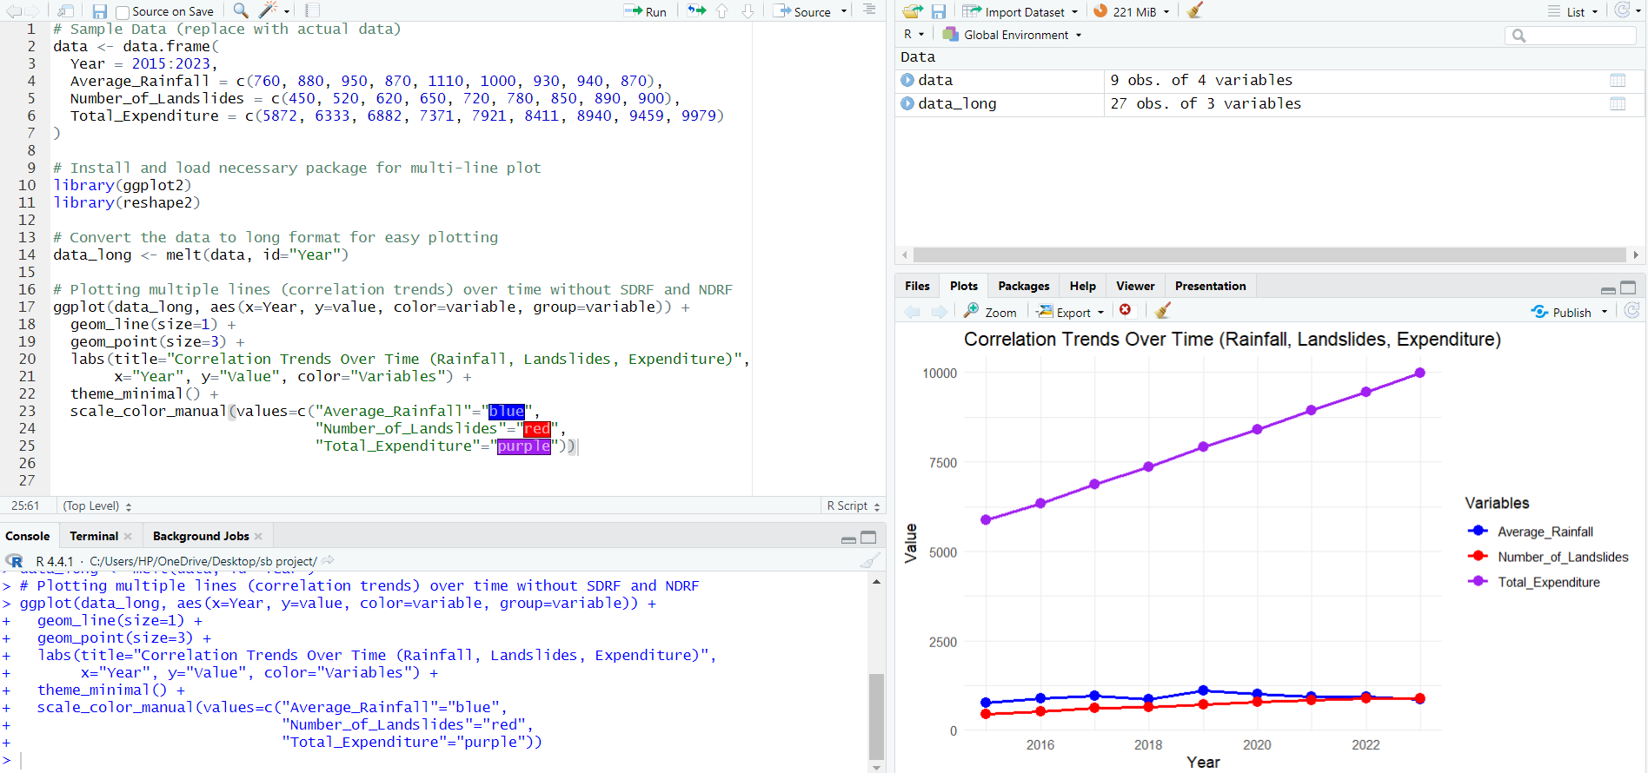

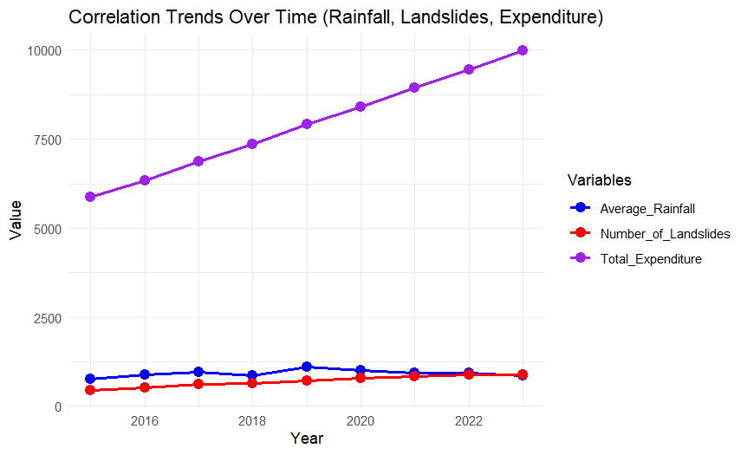

**TIME SERIES**

**Conclusion from the Time Series Plot:**

Based on the time series plot, we can observe the following trends between **Average Rainfall**, **Number of Landslides**, and **Total Expenditure** over the period 2015-2023:

1. **Average Rainfall**:
   * Rainfall fluctuates over the years, with significant increases in certain years (e.g., 2019 with the highest rainfall).
   * It appears to impact the number of landslides, as rainfall increases seem to correspond to higher numbers of landslides.
2. **Number of Landslides**:
   * The number of landslides shows a rising trend throughout the years. This could indicate that more landslides are occurring over time, possibly due to increasing rainfall or other contributing factors such as deforestation, land use changes, or urbanization.
   * The peak in landslides aligns with years of high rainfall (e.g., 2019 and 2023).
3. **Total Expenditure**:
   * Expenditure also shows a steady increase over the years. As the number of landslides rises, total expenditure, which includes relief, rehabilitation, and infrastructure repair, tends to increase.
   * There is a strong relationship between the number of landslides and expenditure. More landslides likely lead to higher expenditure as more resources are allocated to deal with damages.

**Key Observations:**

* **Rainfall and Landslides**: There is a visible relationship between increased rainfall and an increase in the number of landslides.
* **Landslides and Expenditure**: As the number of landslides increases, total expenditure rises. This is logical because more disasters lead to higher costs for recovery and repair.
* **Trend**: Over the 9-year period, all three variables show an increasing trend, which suggests that disaster management and prevention strategies may need to adapt to growing risks and costs.

